# Design 1

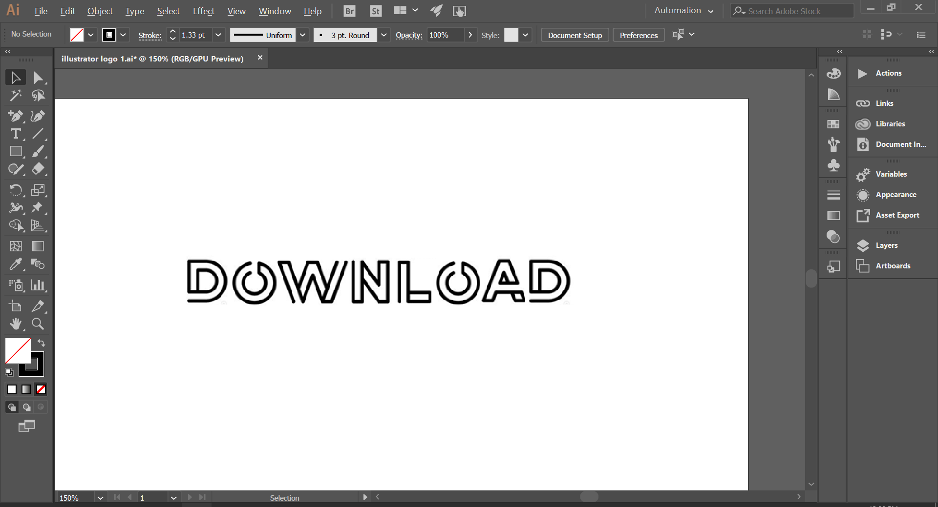

First, I **imported** an image of the font I’m going to use, with the word “Download” already spelt out. I did this simply by copying and pasting the image into illustrator(**ctrl + C, ctrl + V**) This is so that I can trace over the images using segments of circles for parts of letters on ‘D’ and ‘O’, and the line tool for the other parts.

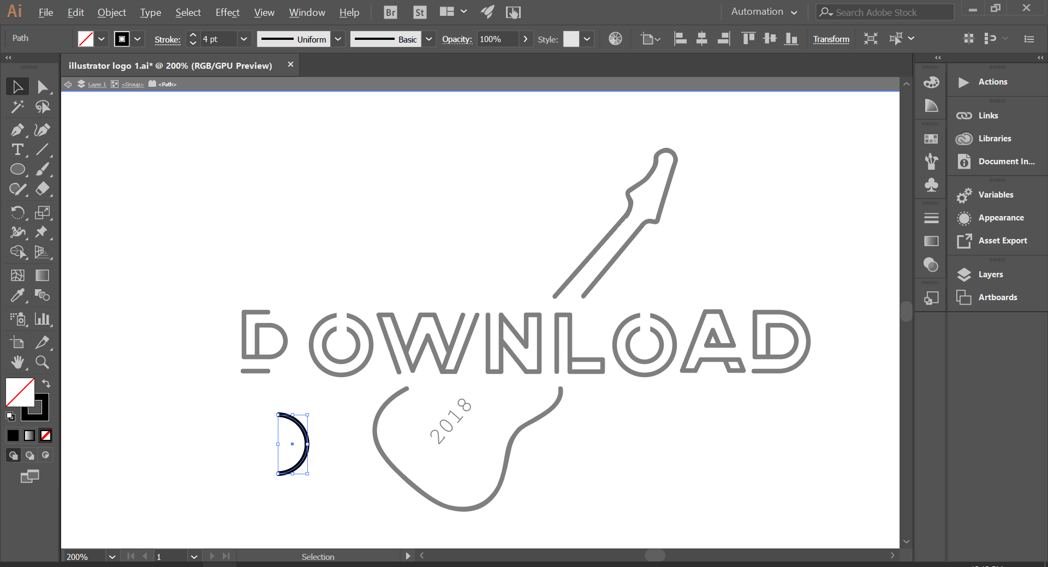

I used the **circle tool** to draw out a perfect circle and used the **Direct Selection tool** to select the far left vertices on the circle and deleted it, which cuts the circle in half, which is going to be used on the curved segments of the letter ‘D’.

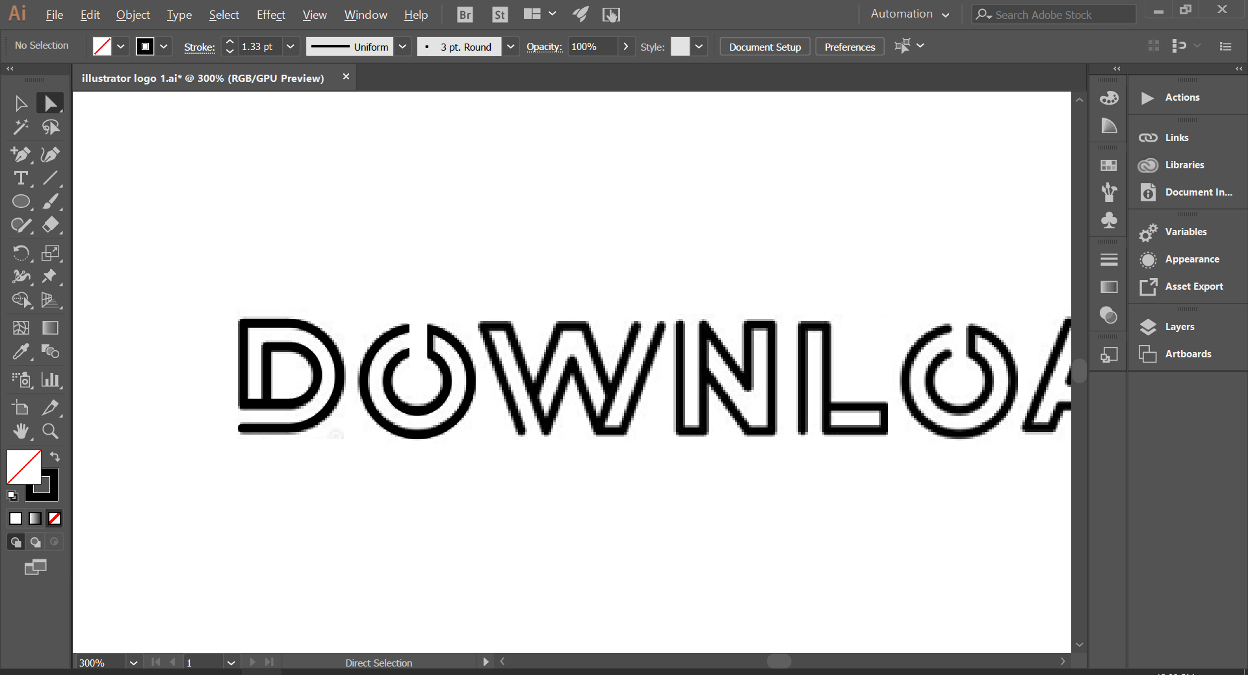

This is partway through the process of tracing, where the letter ‘O’ has now been traced. It’s not clear hear but the background image and the tracing are both on the screen. The letters appear fuzzy due to the **anti-aliasing** on the image I am tracing.

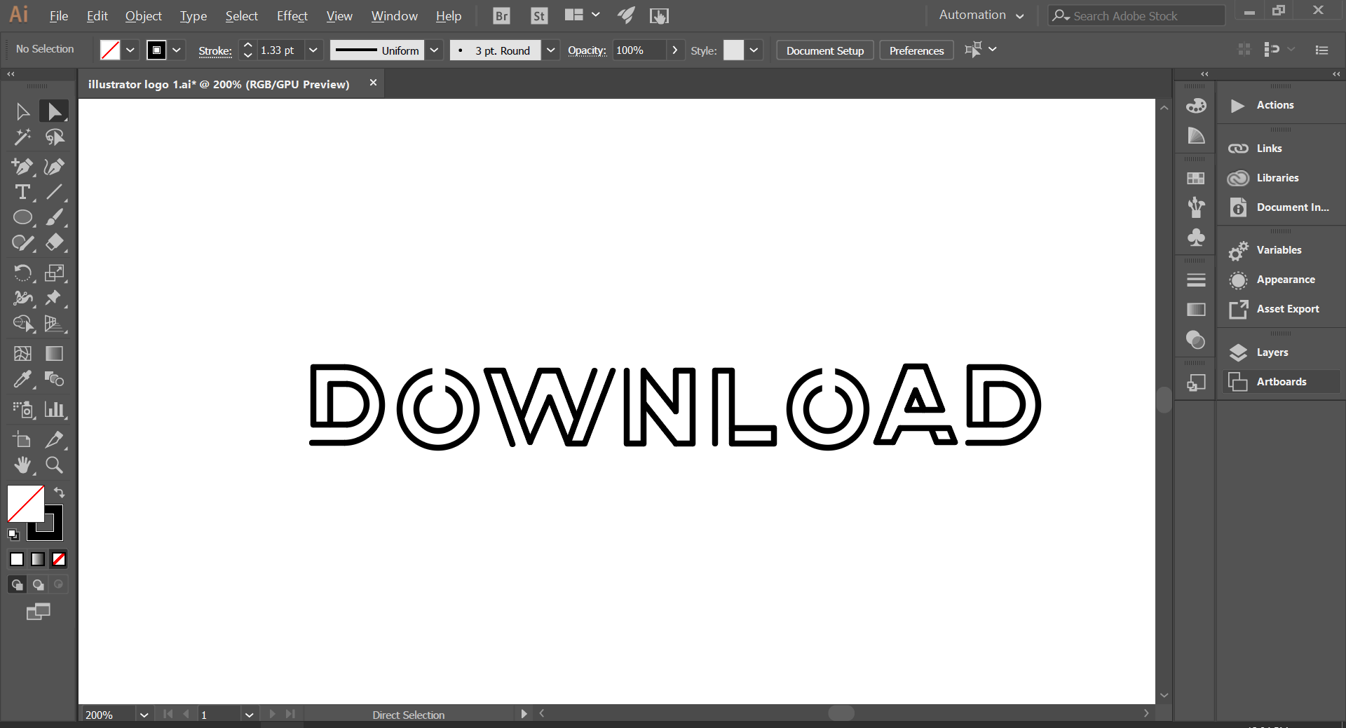

This is after all the letters have been traced, with the writing now finished, I can move onto the guitar. The background font has been removed at this point, however I just **hid the layer** rather than deleting the image in case I need it again later.

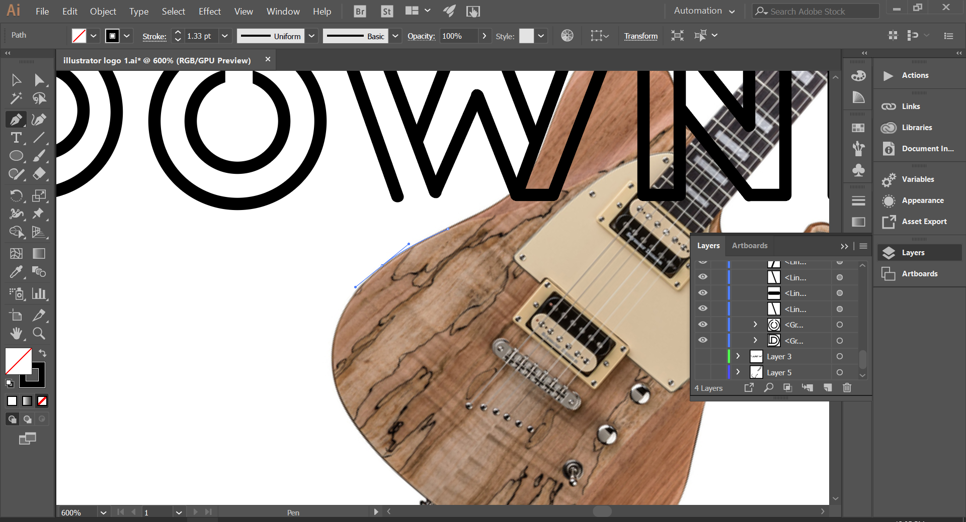

I imported an image of a guitar from google images and started to trace around it is using the **pen tool**. By holding left click and dragging, I was able to create curved segments which allowed me to follow the curves of the guitar with the tool.

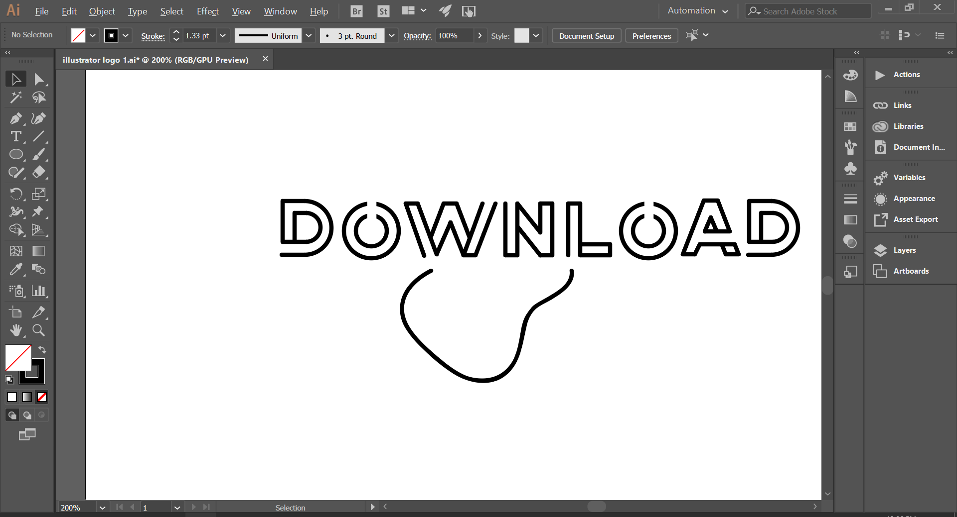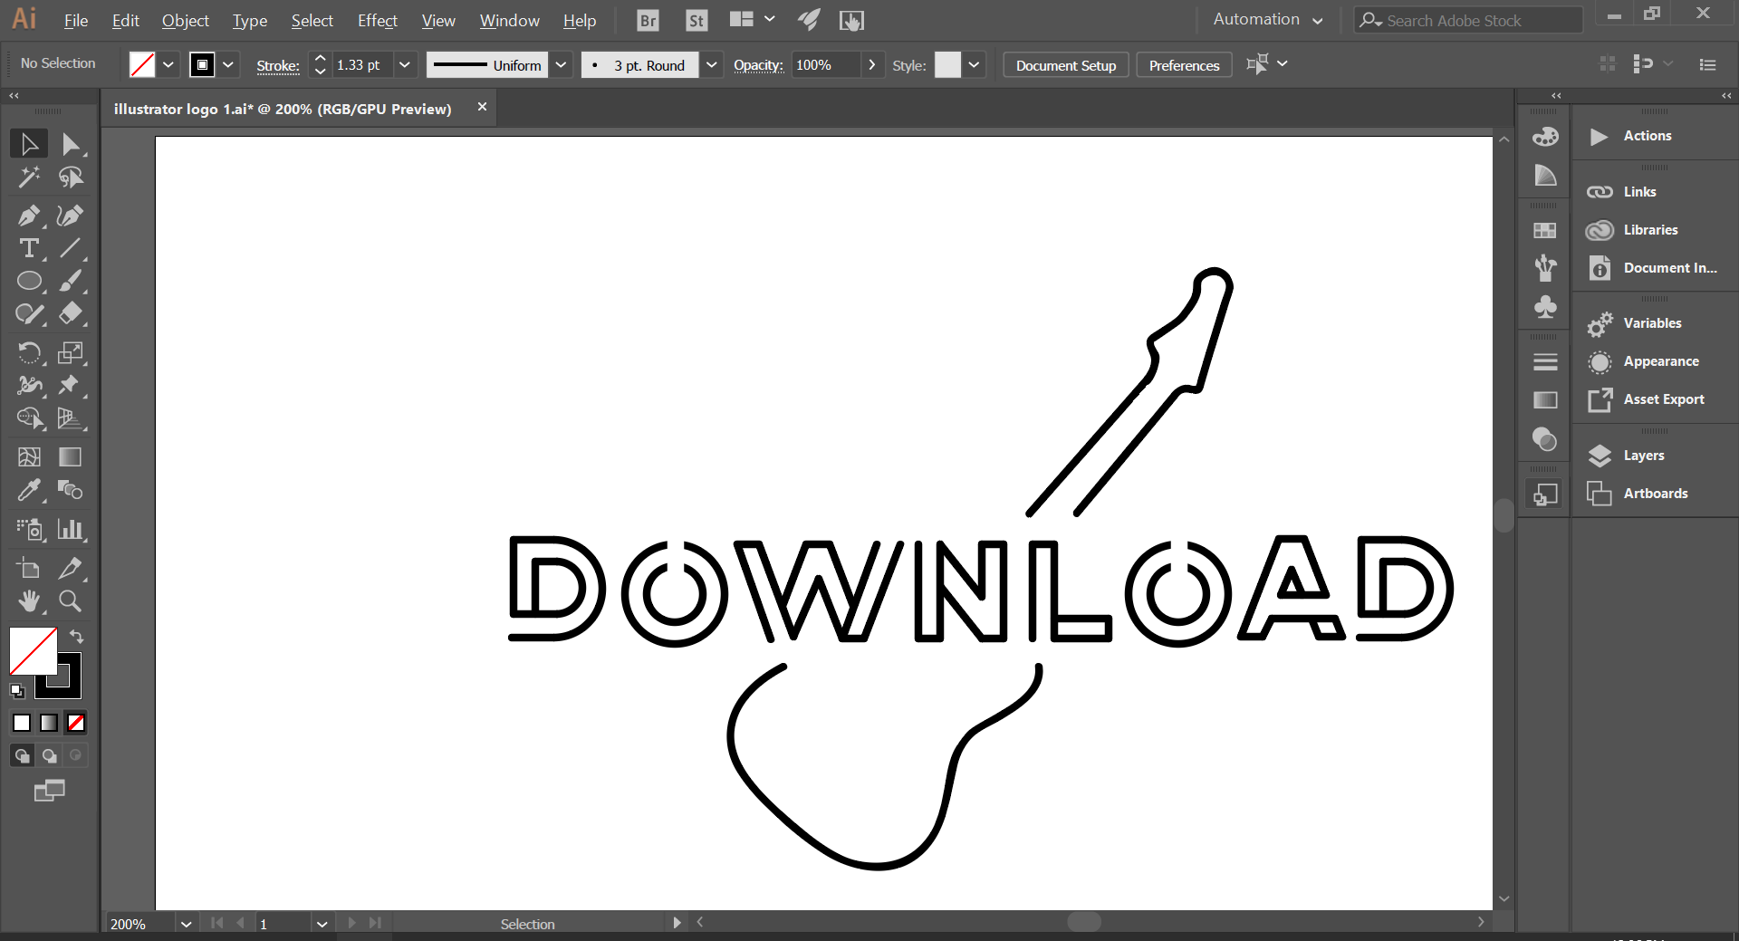

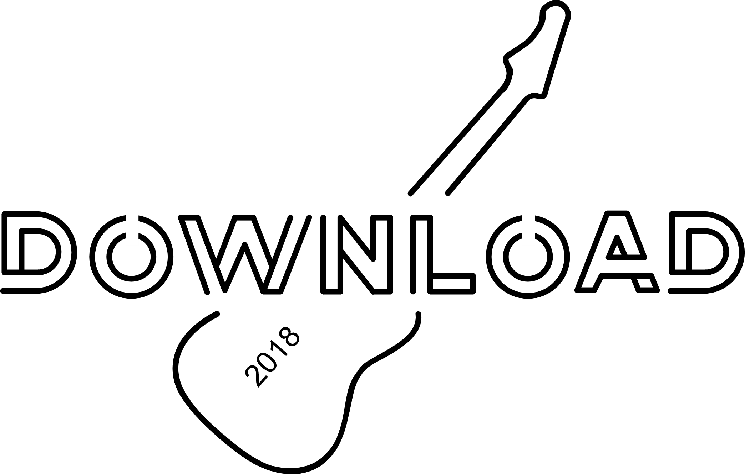

The finished logo is very minimalist, and visually appealing. Although there isn’t a lot of detail on the guitar itself, the shape is very clear and its easy to see that it’s a guitar. This links the logo back to the festival has it is a rock and metal festival, which heavily features guitars. The pros of the logo are that it is easy to read and looks visually pleasing. this makes the logo easier to look at and makes the festival in general more appealing, because the clean look could attract some viewers. However, this may not necessarily be a good thing because the logo doesn’t necessarily attract the target audience, bringing me onto the cons for the logo, which is that the logo doesn’t appeal to the target audience, meaning people who would actually enjoy the festival may not realise what type of music is going to be played at the festival. the target audience would be expecting a more messy or hardcore logo representing the type of music they listen to. Because of this it means that this development of the logo doesn’t represent the brand well, however I think that elements of this logo could be adapted or removed to make the logo suit the audience and the brand better, such as making the lines less clean.